IFF-service

Pom.xml

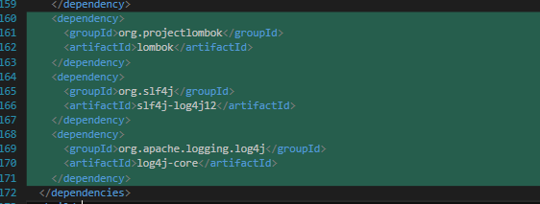

IFFDomainServiceImpl.java

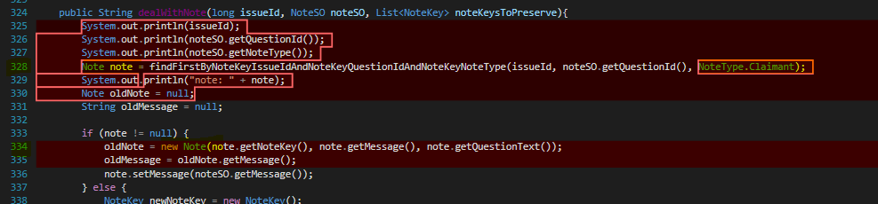

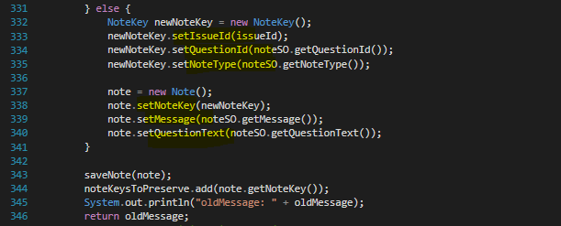

Note.java

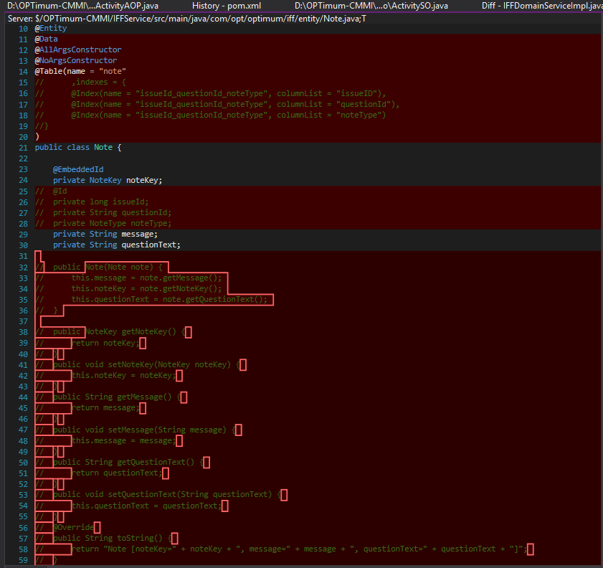

NoteKey.java

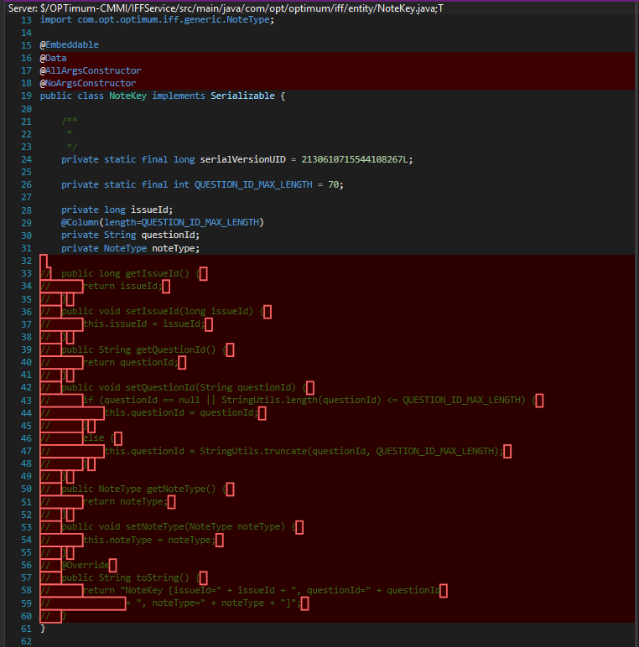

IFFDetailsResponseSO

IFFNoteActivityQueueSO

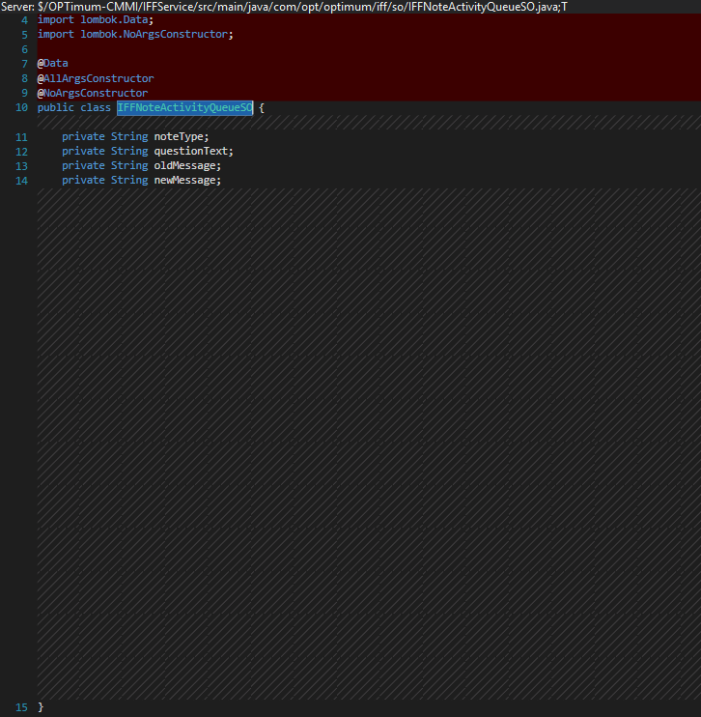

NoteSO

ActivitySO

